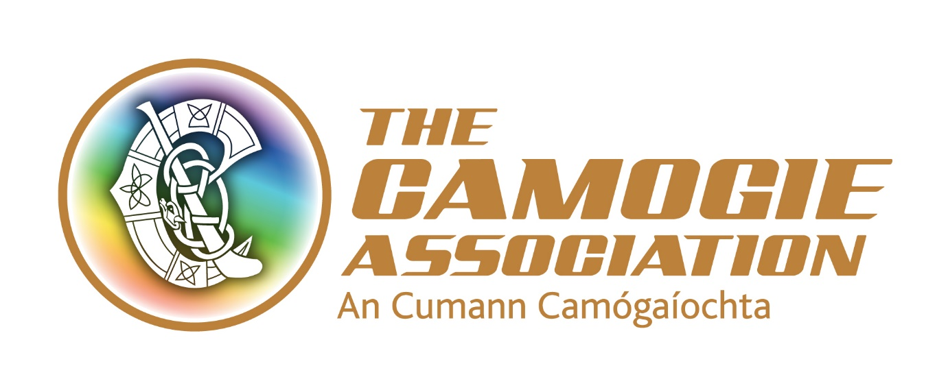

Player Welfare Co-ordinator
New Role
The Association is working to a National Development Plan Our Sport Our Future 2016-2019. This post has a key role to achieve the objectives and targets outlined in these. One of the key objectives of the Plan is to put the club and county player at the heart of everything we do.
The key purpose of this new and innovative role is to develop and manage player welfare support initiatives at club and county levels within the Camogie Association.

The post holder will be an employee of the national Camogie Association. The post operates in a team environment and the post holder will be expected to work in a collaborative way with staff and volunteer colleagues. From time to time the post requires working unsocial hours including weekend work and travel.

The post holder will be based in the Camogie Association’s national office in Dublin with a requirement to also work in other locations, given the national and local brief of the role.

The post is offered for a 3 year fixed term contract.

The successful applicant must have a clean driving licence; her/his own transport and will be
required to comply with Garda/PSNI vetting clearance in advance of taking up the position.

Salary: The appointment will be attached to a salary scale €31,400- €36,700.

Expenses such as travel, overnight accommodation where required and other allowable expenditure will also be paid.

Annual Leave: 23 days’ annual leave. There is additional annual paid leave in the Christmas Eve/New Year period.

Other terms and conditions include:
- 7% pension contribution by the Association subject to matched employee contribution
- A time in lieu facility (TOIL) for work in excess of weekly contracted hours
- Study leave
- Travel (bike to work scheme/tax saver commuter tickets)

Interviews: Interviews are scheduled for the 28th and 29th March 2017 in Dublin.
Closing date for applications is 5.00 p.m. Friday 10th March 2017.

Please return applications to jobs@camogie.ie or to Recruitment, Camogie Association, Croke Park, Dublin 3

===========================================================

Player Welfare Co-ordinator Job Description

The key purpose of this role is to develop and manage player welfare support initiatives at club and county levels within the Camogie Association.

Key responsibilities include:

- Plan and oversee the implementation and facilitation of co-ordinated programmes of activities and events, budget spending, materials production and distribution, and other resources to support player welfare
- Establish and monitor player welfare needs of both club and county players related to supporting and/or enhancing their playing performances
- Design, develop and/or implement programmes to address these needs, drawing on sports science and other relevant expertise as appropriate
- Manage and communicate a strategy for the roll out of a player welfare model with all key stakeholders
- Establish, monitor and prioritise player supports to enhance the enjoyment and longevity of players in Camogie
- With relevant key stakeholders, manage and implement education projects on player welfare issues
- Act as the Anti-Doping officer of the Camogie Association
- Liaise with relevant coach education structures and programmes to improve coaching and management standards to promote player welfare at underage, adult, club and county levels
- Service the Camogie Association Player Welfare Committee
- Liaise with relevant player welfare representatives and structures
- Support and assist the implementation of the Government Scheme to Support Inter County Camogie teams
- Support designated counties
- Supervise and support interns, work placements and occasional contract work as appropriate
- Support the roll out of national programmes and initiatives under the Camogie Association’s National Development Plan
- Liaise with relevant Ard Chomhairle committees and Camogie Association units as appropriate
- Represent the Association
- Undertake any other duties as requested by the Ard Stiúrthóir

Person Specification
Applicants should if called to interview, be able to display and provide evidence of the following
qualifications/training, experience, specialist knowledge, skills/abilities and personal qualities outlined below in this person specification.

Essential criteria
- A third level degree in sports science or other relevant areas
- A minimum of 2-3 years’ professional experience in a similar role
- Practical experience of designing, developing and/or implementing education and awareness programmes
- People focused with the ability to establish strong effective relationships with key
stakeholders
- Practical experience of analysing, developing and coordinating support services for key stakeholders and capable of dealing with changing priorities and situations
- Ability to influence others
- A high level of proven organisational and administrative ability including IT skills
- Excellent communication skills – verbal, written and presentational.

- Self-starter with ability to also work within a team environment

- Clean full driving licence and own transport

Desirable criteria

- Experience of working in the sports sector, especially working with female athletes
- Knowledge and understanding of learning methodologies appropriate to young and adult learners
- Knowledge and understanding of the Camogie Association Player Pathway Model
- Knowledge of the Camogie Association and its structures
- Experience in dealing with volunteers/organisations in a support capacity

At the time of writing, indicative work in this area includes education programmes on player insurance, concussion protocols, helmet safety, asthma management, injury prevention and rehabilitation, nutrition
At the time of writing these are Monaghan, Cavan, Armagh and Louth

