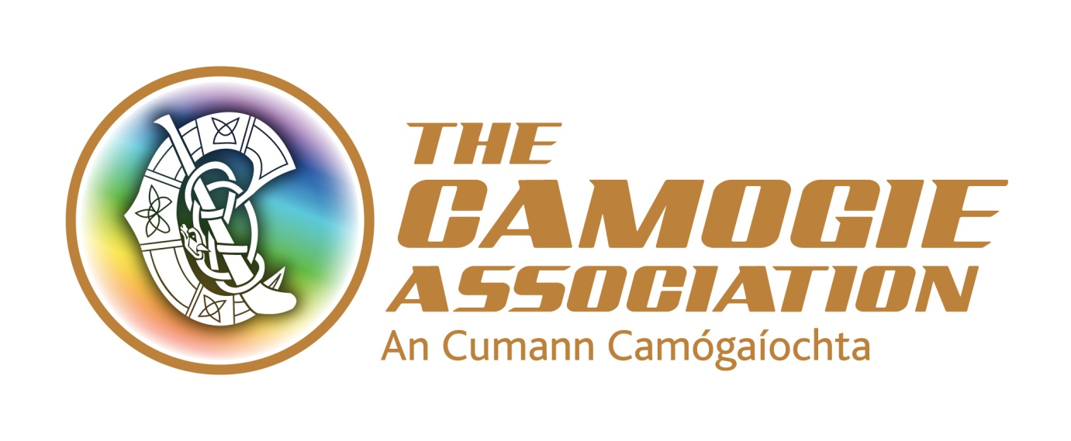
Finance Administrator – temporary full time post to end of January 2018
The Camogie Association is seeking applications for the position of Finance Administrator to join its national office in Croke Park. This is offered as a fixed term contract until the end of January 2018 and may be subject to an extension.
The Role
The Finance Administrator will report to the Finance Manager. The main responsibility of the post is the maintenance of financial records, the processing of income and expenditure, purchase of goods and services and the undertaking of a range of financial reporting and administrative tasks. The post operates in a team environment and will be expected to work in a collaborative way with staff and volunteer colleagues.
From time to time the post requires an element of working unsocial hours including weekend work and travel.
Salary range: €25-28k plus expenses (travel, overnight accommodation costs where required, other allowable expenses in accordance with policies approved by Ard Chomhairle (Central Council) of the Camogie Association.
Annual Leave: 23 days’ annual leave pro rata. A time off in lieu (TOIL) system also operates.
Responsibilities of the Finance Administrator
- Administer Accounts Receivable and Accounts Payable
- Administer online membership registration system including reconciliation of payments received.
- Process sales invoices
- Administer day-to-day finances
- Lodge cash/cheques and manage online banking including online payments and transfers
- Prepare monthly accounting reconciliations including bank reconciliations
- Administer credit control/debt collection
- Administer and processing of purchases invoices and the payment of invoices and staff and volunteer expense claims
- Ensure financial controls are adhered to
- Assist in preparation of year-end audit
- Assist in preparation, administration and control of annual budget
- Administer the sale, stock control and promotion of Camogie merchandising
- Improve and administer controls for collection and reconciliation of income collected/tickets sold as admission to Camogie games under the auspices of Ard Chomhairle (Central Council) and support units to administer these controls
- Develop and administer financial procedures relating to development initiatives and coaching and games activities
- With the Finance Director, improve financial controls within the organisation
- Assist with procurement and risk management processes
- Liaise with camogie units re financial procedures and year-end accounts
- Assist Communications and Operations Team at various Camogie events
- Undertake any other duties as requested by the Finance Manager or Ard Stiúrthóir
Person specification
Essential criteria
- Accounting Technician qualification and/or up to 2 years’ experience in a similar role
- Excellent IT Skills, particularly in Excel & MS Office Package
- Excellent organisation skills
- Good general accounting experience; with sound debit and credit comprehension and reconciliations experience
- Previous experience in financial control
- Strong knowledge and experience of accounting software packages

Desirable criteria
- Hands-on experience in small/medium organisation desirable
- Experience of working with community and voluntary organisations, especially in the sports sector is an advantage
- Ability to work on own initiative

