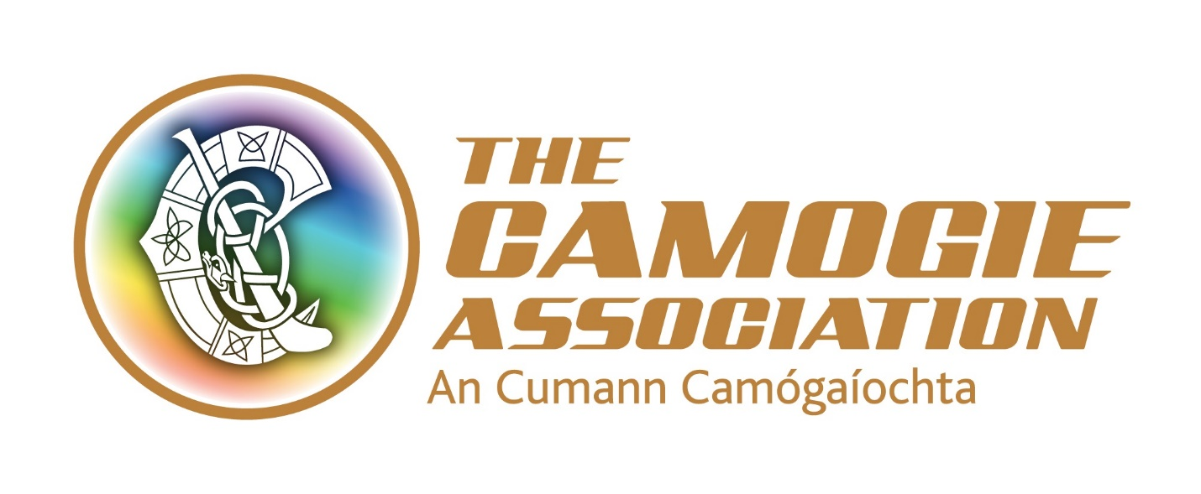

VACANCY
For
Learning and Development Co-ordinator
The Camogie Association is seeking to appoint to a Learning and Development Co-ordinator.
The post can be based at Camogie Association’s national office in Athlone, Armagh, Dublin or Limerick.

From time to time, the post-holder will be required to work unsocial hours including weekends. Travel will also be required.

The successful applicant must have a clean driving licence; access to her/his own transport and will be required to comply with Garda/PSNI vetting clearance in advance of taking up the position.

Salary: The post is a permanent position with 9 months probationary period. The post is attached to a 7-point salary scale ranging from €31,400-36,700 with the first point of the scale anticipated as the initial salary offer to the successful candidate.

Expenses: Expenses such as travel and subsistence will be paid in accordance with Association policy.

Annual Leave: 23 days’ annual leave. In addition, there is additional annual paid leave in the period Christmas Eve/New Year

Other terms and conditions include:
- 7% pension contribution from the Association and subject to employee contribution
- A time in lieu facility (TOIL) for work more than weekly contracted hours
- Study leave
- Travel (bike to work scheme/tax saver commuter tickets).

Interviews for this position will be on Monday 18th December 2018 in Croke Park.
Role of the Learning and Development Co-ordinator

Reporting to the Ard Stiurthoir/CEO, the key purpose of the Learning and Development Coordinator is to focus on strengthening the capacity of Units, officers and staff to grow our sport at all levels.

The post-holder will plan and oversee the development and delivery of education, training and support initiatives in areas such as governance and compliance, leadership, planning and day to day administration of units such as child safeguarding, data protection, membership registration, games development, fixtures planning, supporting players, communications, marketing and business development.

The Association works to a National Development Plan Our Sport Our Future 2016-2019 and to annual work programmes. The Plan is downloadable from
http://www.camogie.ie/national-development-plan.asp
National Development Plan 2016-2019 - 'Our Sport, Our Future'

Key responsibilities of the Learning and Development Co-coordinator

1. Supporting Camogie units
- Support designated counties and supervise interns, work placements and occasional contract workers working on Camogie growth and participation initiatives in these counties
- Support counties and Provincial Unit Executives to develop and implement effective succession planning for key officer positions
- Regularly review and support County Board and Provincial Council Executives to comply with the administrative requirements of the Camogie Association Official Guide
- Line manage the Provincial Participation Growth Officers in Munster, Leinster and Connacht
- Roll out of national programmes and initiatives under the Camogie Association’s National Development Plan

2. Learning and development
- Facilitate volunteer officers, Unit Executives and staff at all levels to avail of appropriate learning and development opportunities
- Co-ordinate and support a panel of high quality experienced facilitators to support the delivery of capacity building and organisational development initiatives and manage relationships with training and other providers
- Research and/or undertake needs assessments to determine new and emerging issues requiring support and to benchmark progress in meeting established needs
- Ensure that all capacity building and organisational development initiatives remain fully compliant with relevant regulations, laws and best practice standards
- Stay informed of and advise on new adult learning methodologies relevant to meeting administrators and staff needs
- Ensure that appropriate performance measurement and evaluation is in place for programmes and initiatives
- Support the alignment of staff learning and development needs with the Association’s priorities and continuously assess these via the staff Performance Management and Review System

3. Plan, manage and report on budget expenditure

4. Liaise with relevant Ard Chomhairle committees and external stakeholders as appropriate

5. Undertake any other duties commensurate with the role and as required by the Ard Stiúrthóir

A staff member’s job description forms part of her/his contract of employment. The roles and responsibilities of staff may change subject to the business needs of the Association, in consultation with the staff concerned.

Person Specification

Essential Criteria

To be considered for this role, applicants must meet the essential criteria below:

- A third level degree relevant to capacity building in organisations, human resources, people development, voluntary or sports sector management or other relevant area

- Two-three years paid experience in capacity building, human resources, people development or volunteer development

- Demonstrated understanding of how people and organisations learn and develop

- Experience of conducting needs analysis and collating information to support development of training materials and conducting monitoring and evaluation

- Experience of developing training materials

- Excellent organisational skills, including an ability to prioritise, work to deadlines and execute tasks

- Demonstrated knowledge and understanding of adult learning methodologies

- Demonstrated ability to think analytically and creatively

- Excellent interpersonal skills and demonstrated ability to develop and maintain positive relationships with key stakeholders

- Demonstrated experience of staff management and budget management

- Excellent communication and presentation skills including report writing skills

- Demonstrated ability to work across and within teams.

DESIRABLE CRITERA

The following will be advantageous to applicants:
- Train the Trainer (QQI Level 6 Module Certificate 6N3325 and 6N3326) and/or Facilitation Skills accreditation (QQI Level 6 Module Certificate 6N3669) or equivalent e.g. City and Guilds
- Experience of working with community and voluntary groups or in the sports sector, especially Gaelic games
- Knowledge of Microsoft Office and other IT related packages

Application process

Applicants must complete the official application form and return no later than 5.00 p.m. on Friday 1st December 2017 to jobs@camogie.ie or by post to:

Stephen Flynn
Operations Co-ordinator
Camogie Association
Croke Park
Dublin 3

Postal applications should mark Confidential on the envelope.

These will be decided post-appointment
These are subject to change. At the time writing, these include Camán to Croker project; Hurl Smart Week and the Annual Volunteer of the Year Awards.

