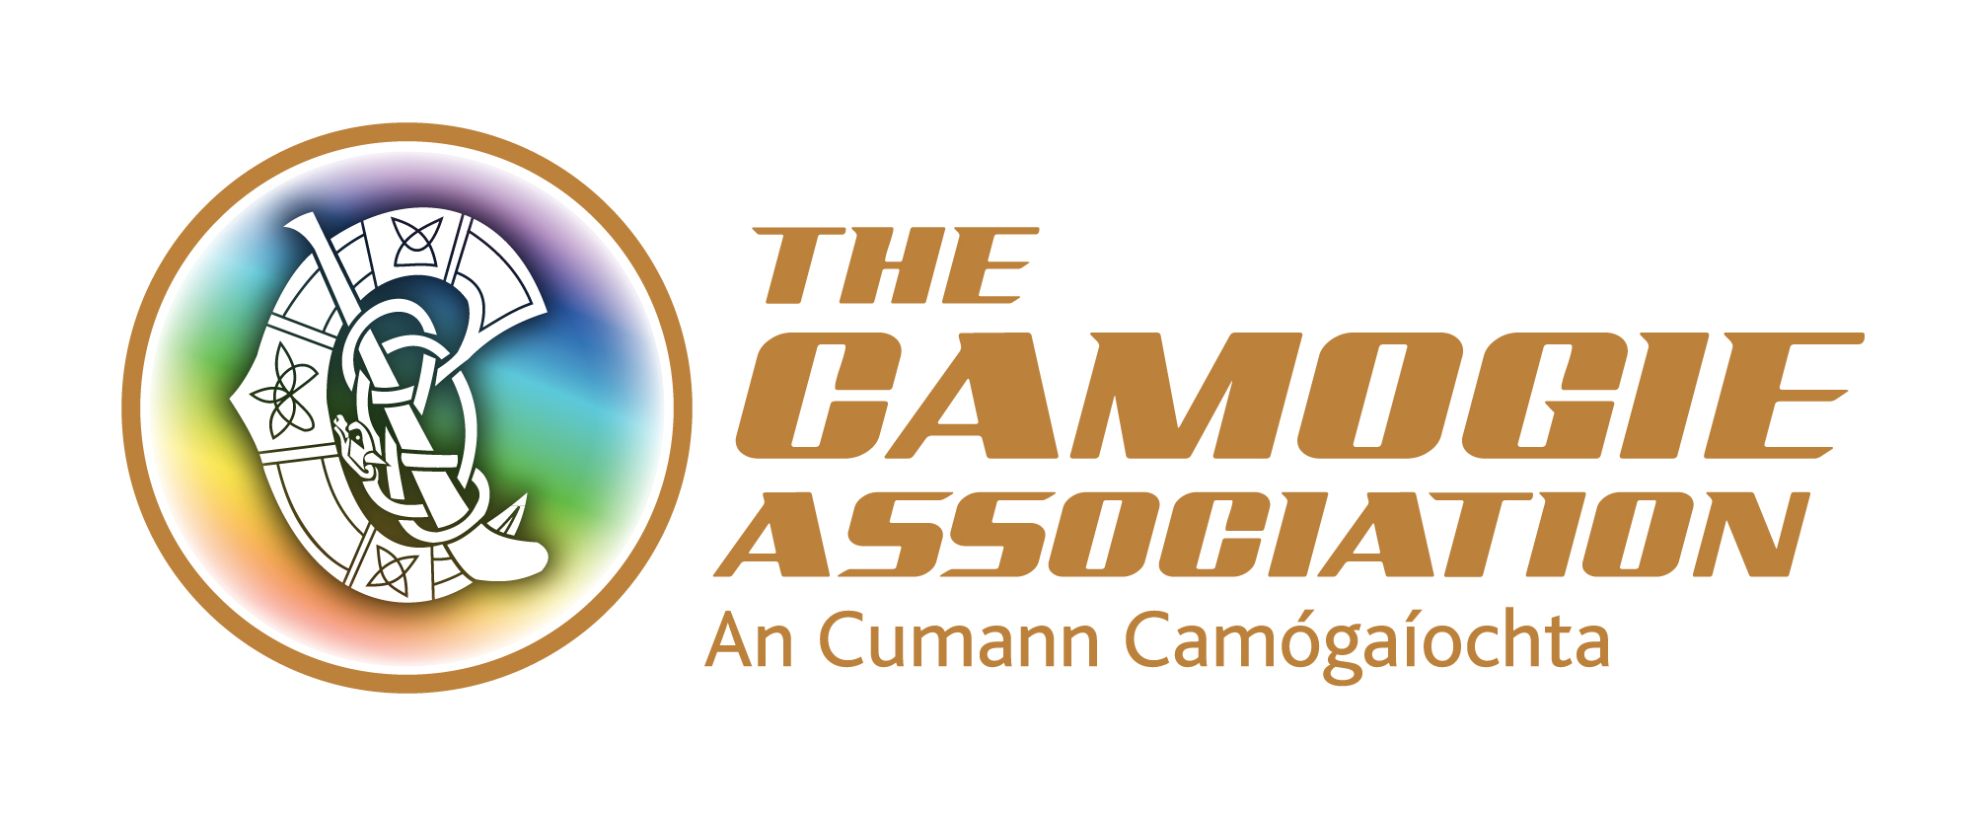
Camogie ‘Volunteer of the Year Award’ 2020
The County Board is seeking nominations from clubs for “Volunteer of the Year” for the season 2020. This award is being made to acknowledge the huge effort made by many people in all clubs within the county during this exceptional year. An overall winner will be selected by the County Board and honored.

The award winners from each County will also be honored at a special awards ceremony which will be finalised at a later date.

Nomination form should be returned to your County Board Secretary

Club Nomination Form

A. Name of Nominating Club ____________________________________

B. Name of Person being nominated for County Volunteer of the Year Award:

_______________________________________________________________

D. Title/Nominee’s role in the Club ___________________________________

E. Explain in detail why the person is being nominated

_______________________________________________________________

_______________________________________________________________

_______________________________________________________________

Síniú an Rúnaí: ________________________________________________________

