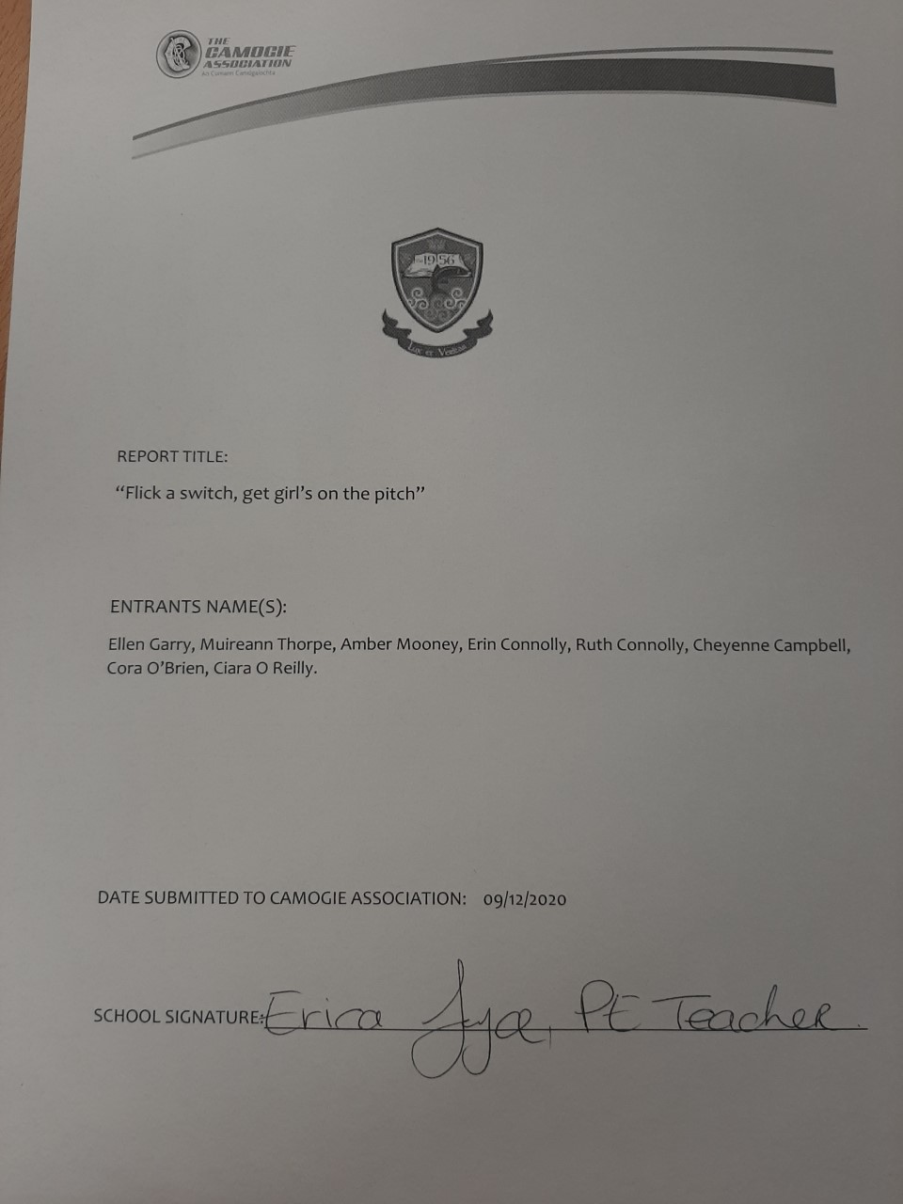
Introduction
Our idea, “Flick A Switch, Get Girls On The Pitch” is a project discussing how Camogie can be a better supported extracurricular for teenagers in girls’ schools and how to get young girls more interested in Camogie.
We decided to do this project as we noticed that in all female schools and co- educational schools, sports is not nearly as supported as it is in all male schools, and we’d like to see this change.
With our project, we hope to be able to get a bigger conversation and more support and aid to Camogie in Girls’ schools.
In our school, there is no camogie team, so we would like to see a team, that has funding and equipment.
Throughout our project we will be considering and finding out why so many young girls who played camogie in primary school may not play in secondary school and what the cause of these young girls quitting Camogie.
We are passionate about this project as we are a group of young girls in an all girls school who are all play sports. As I said, not all of us play camogie specifically, but we still have a passion for the matter and believe that camogie should have more recognition.We would also like to be able to motivate the younger girls in our school who play camogie to be able to continue the sport they love and get a group of new people to find a love for camogie.

Method
We have come up with many plans and methods that will help achieve our goal of getting more teenage girls interested and involved in playing camogie.
One of these methods would be to start introducing camogie sessions into some of the first year’s PE classes. We could achieve this by giving up our own time once every month to coach and teach the first year girls how to play camogie during their PE classes. We would be teaching them some basic skills by doing drills such as learning how to pick up the sliotar and learning how to hit the sliotar off the hurl. We would also be running fun games and workshops to keep the girls interested and make sure they were enjoying themselves. By doing this we would hope to be familarising the young girls to camogie in a fun and pressure free environment at a young age, in hopes that they will develop a love for the game and will then want to continue playing camogie.
We were also thinking of having weekly competitions such as “ how many times you can bounce the sliotar on the hurl in a minute” or “ how many times you can hit the sliotar against the wall” where the girls with the top three scores could win a prize. We will let people know about these competitions by explaining when and how they will be run over the intercom, then we will find out our winners by getting the competitors to send in videos of them completing the task as proof for us to know that they have completed the competition correctly and fairly. Finally we will tally the scores and give the three top scorers a prize such as a sliotar or Hurley grip. By running these competitions we will be hoping to motivate the girls into wanting to develop their skills and love for camogie.
Lastly, we were hoping to get recognised camogie players to send in short videos to us that we could show the first-year girls during their tutor class. In these videos we would get these camogie players to talk about the experiences and opportunities they got from playing camogie and to also give advice to any of the younger girls who were thinking of starting camogie. We would hope that these videos would inspire the young girls and also introduce them to all the opportunities that will come your way when you play camogie.

Results
With our project “Flick a switch get girls on the pitch” we hope to achieve a stronger interest and uptake of camogie in all girls secondary schools all across Ireland.
What we would like to see at the end of this project would to be for Eureka secondary school to not be just a football and basketball dominant school but to have a strong camogie team as well that has proper funding and equipment including hurls, helmets and sliotars. As we have included in our methods we would like to involve the first years at our school as much as possibly can as we have noticed a majority of Eurekas first years have no camogie backgrounds due to a lack of skill workshops and encouragement in primary schools.
After our PE sessions we are hoping to have with our junior cycle students, we would love for them to get the experience and have learned the basic skills and this might encourage them to develop an interest so that there should hopefully be a greater demand for a school camogie team. We are aware that a number of our students in our school throughout all years have dropped out of camogie due to a number of different reasons such as lack of encouragement, being unsuccessful in camogie when they get to older years as it can be quiet intimidating and a number of girls often drop out because some of their friends do. We aim to make camogie a more fun, welcoming and less frightening environment for all girls in our school. We believe that our aims are very realistic and we hope to see a change in the lack of support and encouragement that people have for girls playing camogie in school teams and outside of school.

