Camogie retention among international students
Rose Saijan, Aksa Johnson, Annabel O’Connell, Mia Costa
Loreto secondary school Kilkenny
2/12/2020

INTRODUCTION
In Ireland, camogie is a big part of our culture, but what does it mean to people who’re not from Ireland? For our project we will be looking at camogie retention but from the perspective of people of different ethnic backgrounds and countries.
We will be reviewing the interviews of students in our school that play camogie and those that don’t. As well as the girls that dropped out and figure out why they stopped playing.
Sport makes a great impact on the life of a teen. It can play a major factor on someone’s wellbeing. It can benefit us socially, physically, mentally and emotionally. Camogie players and people who take part in sport can develop qualities like resilience, discipline and teamwork. Taking a look at the numbers, only a staggering three in ten (32%) of the Irish population are considered to be sufficiently active to meet the national guidelines. Six out of ten (37% overweight and a further 23% obese) are overweight or obese. These numbers can be changed by encouraging all people to take part in sport
We believe it’s important to put an emphasis on the fact that genuinely anyone can get involved with sport. Factors like age, gender, religion, experience and race should not be a reason for people to hesitate, refrain or drop out of sports. The numbers are fairly small when it comes to the amount of people from different countries who play camogie. We’ve taken it upon ourselves to research how international students feel about camogie and based on these answers we can take the first few steps forward to making all people of different nationalities feel welcome.

Method and reasoning
Our main idea was to introduce role models to people of minority and/or get more coaches from ethnic backgrounds. Sportswomen of colour/different nationalities who can set an example for girls who feel discouraged from starting up camogie. They can share their stories and experiences of being a minority, which could help people relate to them. This could be a big aid to people who feel they aren’t represented enough. We interviewed a few Camogie coaches in our school to hear their thoughts. When asked about the numbers of international students in camogie they all answered that there were very few in numbers or they’ve seen people take part in first year camogie but none with the older age groups. They believe this could be the case for the following reasons;

“I think that kids are inspired by what they see and there are very few role models of different nationalities in the GAA at the minute. Children need to be encouraged to play GAA in primary school and have a positive experience of the sport with their local GAA clubs.”

When asked how this issue could be approached the following was said;

"It would be a good idea to show international students examples of intercounty GAA players with ethnic backgrounds. Athletes such as Boidu Sayeh (Liberia) who plays Gaelic Football for Westmeath and Zak Moradi (Iraq) who plays Hurling for Leitrim would be great examples to show that it is possible for international students to excel at GAA."

Another issue that arose amongst the girls we interviewed was racism and discrimination. Racism and discrimination in any form, indirectly or directly, can be severely damaging to anyone’s wellbeing. There have been instances where the girls felt as if they were being treated differently to other Irish girls and this is not tolerable at all. This can be stopped by confronting all signs of prejudice towards people of colour. You might hold absolutely no racist beliefs yourself but by any chance if you happen to witness or hear of discrimination, prejudice or bias amongst your team, it has to be handled immediately. A lot of these girls just want to fit in but something like their skin colour should not be a reason for someone to be judged or treated .
Another major reason for the small numbers was because of people’s different cultural upbringings and the time at which you start up camogie. For example most Irish girls have been brought up with camogie whereas the same can’t be said about families of different nationalities. We sent out a survey in regards to this and we asked students about when they started up camogie and the results are as follows;

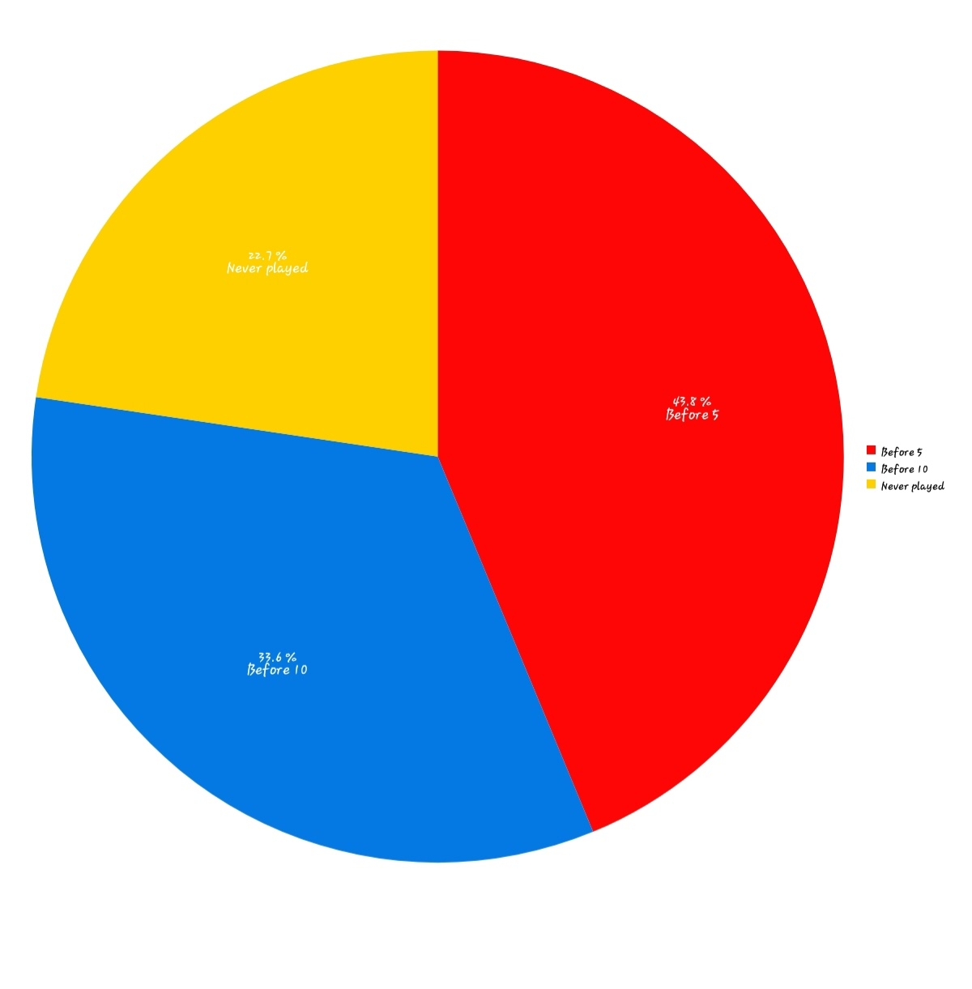
A grand 77.4% said they started before the age of 10.

When asked for the reason for starting up camogie a good number of people said because of their families. Other major factors were because of friends and others said they just got hooked on the sport and enjoyed it.
Another proposal we had was for the GAA or schools to have clubs where beginners of all ages could play together so they won't feel as if they'll be judged for not being as advanced as others. They can move to other teams depending on their age group once they feel comfortable.

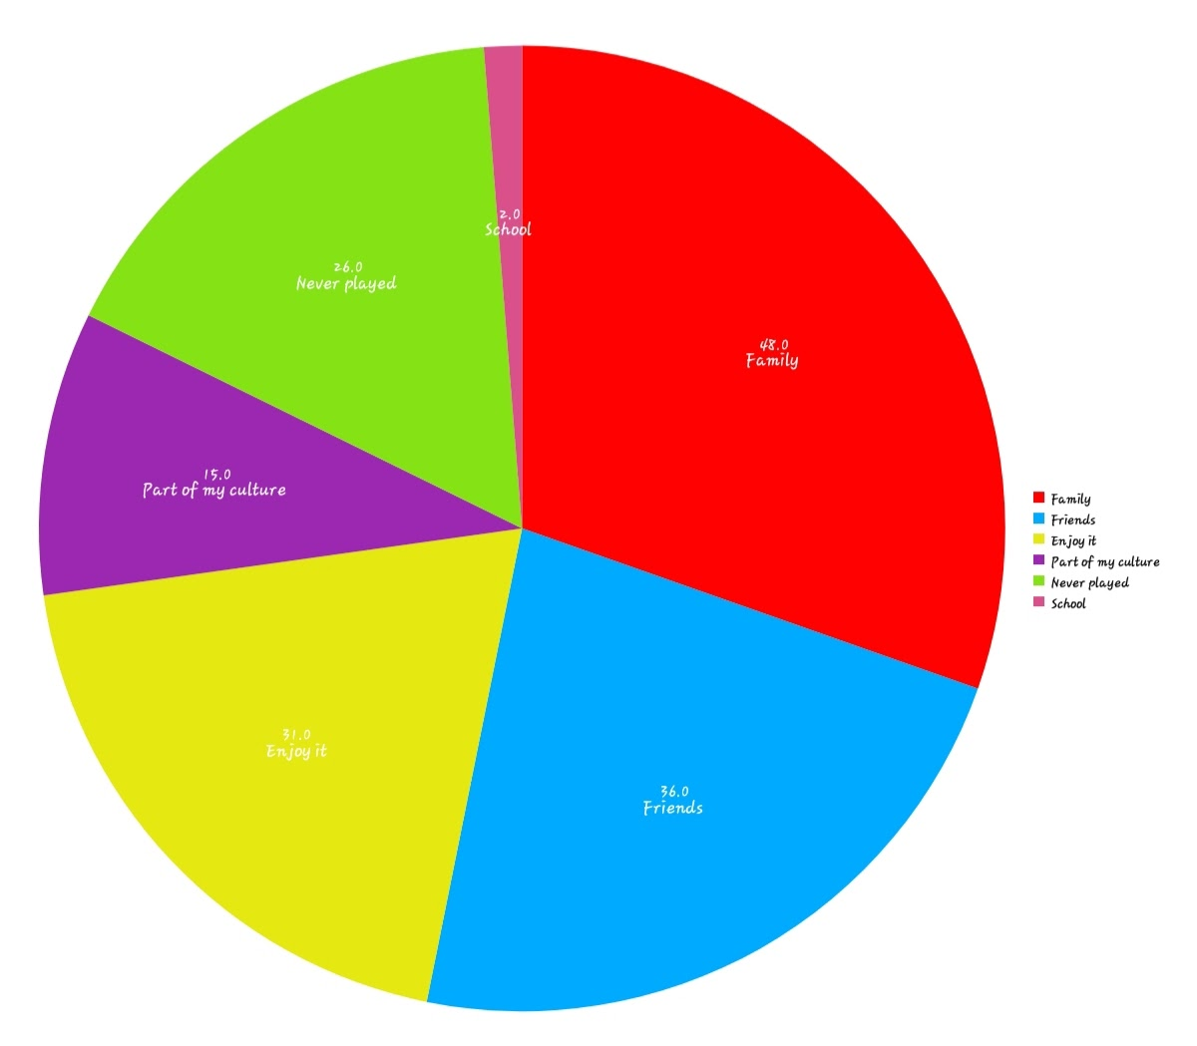

Interviews
For our interviews, we interviewed some of our friends that are from different nationalities to see their take on camogie.

India
- Have u ever played camogie?
Yes
- Where are you from?
India
- Are you still taking part in camogie?
No, I stopped playing
- Why did you stop playing?
I felt kind of discriminated against, the coaches were a bit passive aggressive towards me compared to the other girls
- Why do you think it’s important to play camogie?
It helps develop your social skills and you make new friends
- Why do u think so many people play camogie?
I think they were made to do it from a young age and also it’s something everyone did because you were considered “popular”
- Do you think you need to start playing camogie from a young age to be good at it?
I think it definitely helps because when you’re younger everyone you’re age is at around the same skill level as you and it’s unmotivating at times when you’re still learning and everyone else is so much more advanced. I started in first year so I didn’t have the same skill set as the people on my team, this made me feel like I wasn’t good enough and I felt like dead weight they had to carry around.
- Do you think many people drop out of camogie because they have to focus more on state exams?
Yes, I think only the really dedicated players stay on to play, because training sessions and matches take up a lot of your time.
- Do you think camogie is good for your mental health? Has it helped your mental health in any way?
It really depends because it can be a nice to have an intense training to take off some stress after a long day but at the same time, you do find yourself comparing everything about yourself to others and one bad match can really make you feel awful.
- Do you think your ethnic background plays a part in you starting up camogie?
Yes, I used to feel really insecure about my ethnicity and wanted to be more like everyone else in my class and do everything they did. So I did it to act more like an “Irish girl” but I felt so different from everyone and to make up for physical differences I tried to act more like them and started to lose my own sense of individuality.
- Why did you pick up camogie?
I did it at first to fit in and eventually I thought I got good at it after some practice but when matches came around I had to think twice.
- Have you experienced any discrimination while playing camogie? Yes, I personally felt a small bit especially how cold the coaches were towards me, usually they’re really friendly to the other girls but only gave me death glares when I missed the ball or did small mistakes. They also didn’t seem to understand that I only started this year and needed more time to get better at the actual sport, this made me feel as if they didn’t actually want me on the team.
- Has the discrimination you have faced played a role in your participation in camogie?
Yes, it made me feel scared to go to training sessions and I would pray that it rained on these days so I didn’t have to go. I didn’t tell anyone about this so they just thought I was lazy or something. I didn’t even know this was discrimination at that time, I thought that there was just something wrong with me and that I wasn’t trying hard enough. But when I look back I only remember giving my all every time. Slowly I started to go to less and less matches and training until I stopped. The day I stopped was like getting the world off my shoulders and eventually I became myself again. This helped me find friends I that I actually had something in common with and could be myself with them
- Would you be more likely to play camogie if more people of colour were playing camogie as well?
Definitely, because this could lead to the coaches understanding that they’re being insensitive because they can’t discriminate against a whole group of people. It would also help because if more people of colour played there would be more coaches in the future of different ethnic backgrounds and therefore bring more diversity into the sports world.

Kenya
- Do you play camogie?
Yes I do
- Where are you from?
Nairobi Kenya
- Are you still taking part in camogie?
Yes I am
- Why do you think it’s important to play camogie? To settle in , mainly to mix with the community as everybody plays camogie and I feel like it’s the best way to fit in and it’s easier to have a conversation with some of my friends because we’d have camogie in common
- Why do u think so many people play camogie?
To fit in mostly, I feel like your more accepted in the Irish community if you play camogie because people think so highly of the GAA in Kilkenny and do not consider other sports possibly because Kilkenny is a massive hurling county so in turn camogie will be too however people are more so born into it and stick with it
- Do you think you need to start camogie at a young age to be good at it?
I believe you do to a certain extent since the girls that would have started younger than you would have a more perfected skill set than me who started at an older age and hasn’t had much experience as the rest of my teammates. But for me I started playing when I was 12 which isn’t too bad however I would say I am quite athletic so it did help a bit
- Do you think many people drop out during the year they do their state exams, why’s that?
People do drop out however only temporarily as training can change your days schedule, as in you lose around 2 hours of work time because generally you get there 10 minutes before , train for an hour , then wave 10 minutes later, then. By the time you get changed and settled back home you’ve already wasted 2 hours of study. It also interrupts your flow, you could have begun something however when you get back you’re not in the right headspace to complete it as training can be exhausting however on the flip side some do continue playing as they like to get a break from the work to clear their heads
- Do you think camogie is good for your mental and physical health?
Yes because any sport in my opinion is, it gives you a chance to disconnect from whatever may be going on at home , school etc. and enjoy the company of your friends while enduring some physical activity at the same time.
- Do you think your ethnic background plays a part in you starting up camogie?
At the start the only reason I started up camogie was to fit in with my Irish friends and to have the same sort of chat as them. But at one point I did feel like I didn’t properly fit in my camogie team because I’m from a different background and everyone on my team was Irish and I felt like the odd one out, I felt as if I had to act more Irish to fit in with my teammates because at the end of the day it was an Irish sport after all and I wasn’t from here. I feel as though people from different nationalities when they settle in a new country they often try to change themselves to adapt to the cultures and customs of the place that they are moving to which is always good but it can also be bad since after a while you find yourself loosing yourself to be someone you are not.
- Have you experienced any discrimination while playing camogie?
Well particularly because I am also tall when I am playing against smaller opponents it may look like I have fouled when in reality I have not so people that this opportunity to give racist nasty side comments which can be a damper on the game. Also some referees I believe are plain out racist , I have been blown for things that are not fouls to which other girls would do the very same thing and not. Obviously I can not blatantly call out the referee for racism because he will deny it and some may look at it and say playing “ the race card “ which is frustrating. Then when I plead my innocence I get a warning for back chat so it’s really just a lose – lose situation. I remember starting up playing camogie I experienced some discrimination since I was a person of colour on the pitch playing a very Irish sport it slowly did pass but sometimes it comes up and I just have too look past it but at the same time it really does mess with you in so many ways.
- Has the discrimination you have faced played a part regarding your participation in camogie?
At times , like it’s definitely not a nice feeling leaving the pitch hearing certain comments especially because it’s these little comments that stick with you for life. Like many there have been days that I’ve just not wanted to go back but I always said I must finish the season to which I did but there have been days I just took a break from it or faked an injury.
- Would you be more likely to play camogie if more people of colour were playing camogie?
Yes definitely, some may say it’s stereotypical but black people just gravitate towards black people as when you are in a predominantly white country with no family, you become each other’s family so it is settling to see another black person playing. Like on the tv you would rarely see a person of colour on the county senior teams which for younger people may make them feel unrepresented and discourage them from joining however the more the merrier. As in the more people of colour the merrier.

Irish (plays camogie)
- Have you ever played camogie?
Yes I have, I really enjoy playing.
- Where are you from?
Ireland
- Why do you think camogie is important?
The social aspect and it’s great fun.
- Why do you think so many people play camogie?
People play because they can belong to a team, they get to see their friends and the sport itself is enjoyable.
- Do you think you have to start camogie at a Young age to be good at it?
Yes I think you would want to join when you are 10, at the latest.
- Do you think many people drop out because of state exams, why?
The odd few would, to study, I guess, I don’t think that that is the right choice though.
- Do you think camogie is good for your mental health?
Definitely, the same as any sport.
- Do you think you ethnic background plays a part in you starting camogie?
Yes, my family would not be involved so much if it weren’t for my background.
- Why did you start camogie?
My friends and family were playing and it is very big in my parish.
- Have you ever experienced discrimination when playing camogie?
No I haven’t
- Would you be more likely to pick up camogie if there were more people of colour or your nationality were playing?
I don’t mind, I already play so whoever wants to join, let them.

Conclusion
In conclusion, we think it’s possible to gain the interest of international students without them having to worry about their ethnic background coming in to play. They should be able to freely enjoy camogie to the fullest like everyone else. We believe this beautiful sport is for everyone to experience. It’s our responsibility as humans to accept each other for our differences, as we all have them. Diversifying camogie could be the first step into Ireland retaining a more diverse sports world. Rather than having to worry about how you’ll be treated at camogie training today, their biggest concerns should be where the sliotar is headed!

