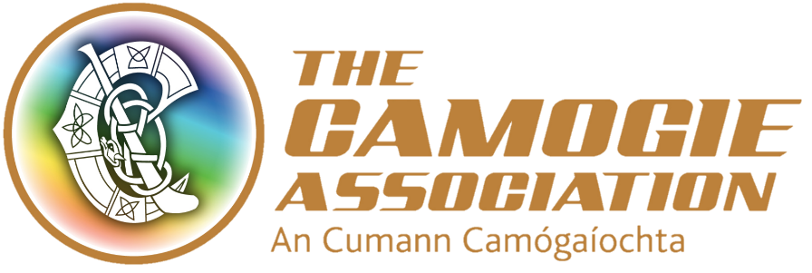

Annual Congress Motions Committee

Terms of Reference

Approved by Ard Chomhairle on 10/06/2020

1.0 Overview
Subject to the overall jurisdiction of Ard Chomhairle (Central Council), the Annual Congress Motions Committee is responsible for approving motions as submitted by County Boards, Provincial Councils, National Education Councils and International Boards for submission to Annual Congress (see Rule 12.4 An Treoir Oifigiúil (Official Guide) Part 1 Camogie Constitution Rules (2019/2020).

- Membership
  - The Annual Congress Motions Committee is a committee under the jurisdiction of Ard Chomhairle
  - The Terms of Reference of the Annual Congress Motions Committee must be approved and ratified by Ard Chomhairle
  - As per Rule 12.4 of An Treoir Oifigiúil (Official Guide) Part 1 the Committee shall comprise of the Uachtarán, the immediate two Past Presidents, the Ard Stiúrthóir and two other members nominated by Ard Chomhairle of four members. Only members of the committee have the right to attend committee meeting(s). The Ard Stiúrthóir may request the attendance of a staff member to attend meeting(s) on an ex-officio basis and provide administrative support to the committee.
  - Nominations to the Annual Congress Motions Committee must comply with Rule 12.4 and must be ratified by Ard Chomhairle.
  - Membership of the Annual Congress Motions Committee will be as set out in Rule 12.4 and membership must be ratified by Ard Chomhairle annually.
  - The Uachtarán will Chair meeting(s) of the Annual Congress Motions Committee
  - The Ard Stiúrthóir or designated staff member will act as Secretary of the Annual Congress Motions Committee

- Quorum
  - The quorum necessary for decisions by the Annual Congress Motions Committee in respect of competition must include those members specifically named in Rule 12.4 and shall be 100% of the committee membership as set out in rule.

- Meetings
  - The committee shall meet at least once a year in January prior to Annual Congress in April in order to facilitate compliance with Rule 12.6 of An Treoir Oifigiúil (Official Guide) Part 1

- Notice of meetings
  - Meeting of the committee shall be called by the Ard Stiúrthóir at the request of the Uachtarán (the committee chair).
  - Unless otherwise agreed, notice of each meeting confirming the venue, time and date together with an agenda of items to be discussed, shall be forwarded to each member of the committee and any other person required to attend no later than seven working days before the date of the meeting. Supporting papers shall be sent to committee members and to other attendees, as appropriate, at the same time.

- Minutes of meeting(s)
  - The Ard Stiúrthóir shall minute decisions of committee in respect of motions and also record the names of those in attendance. Draft minute of decisions taken at committee meeting shall be circulated promptly (but no later than 4 working days after meeting) to all members of Annual Congress Motions Committee. Once approved, minute of decisions should be made available in physical form or through a link to a digital repository to all other members of the Ard Chomhairle.

- Duties
The committee shall: (as set out in Rule 12.4)
  - The Committee will approve motions as submitted by County Boards, Provincial Councils, National Education Councils and International Boards for submission to Annual Congress.
  - The Committee may put a motion in order where there is a failure to quote the numbers of the Rules affected or where there are minor clerical errors.
  - In the case of a motion submitted by a County Board, Provincial Council, National Education Council and International Board not being in order, the relevant Units will be advised in writing of the reason(s) for a motion being not in order, and subject to a time-limit determined by Ard Chomhairle, will be afforded an opportunity to resubmit an appropriately corrected motion for the consideration of the Annual Congress Motions Committee.
  - In addition to role of committee as set out in rule the committee chair will where possible ensure that the rationale has been sought in advance of meeting in respect of motions from counties, provinces, education council and international board which are not worded in a manner to assist the committee to decide whether motion is in order.

- Reporting responsibilities
  - In respect of Section 7 above the committee chair (Uachtarán) will provide written confirmation to Ard Chomhairle in relation to the decisions taken by the Annual Congress Motions Committee.

- Other matters
The committee shall:
  - Have access to sufficient resources in order to carry out its duties, including access to the Association’s staff for assistance as required
  - Be provided with appropriate and timely training, both in the form of an induction programme for new members and on an on-going basis for all members
  - Review its terms of reference annually and make recommendations for any changes to the Governance Committee

- Authority
  - The committee’s authority is as set out in Rule 12.4 and membership is ratified by Ard Chomhairle.
  - The committee’s authority on any matters rests within its terms of reference subject to prior approval by Ard Chomhairle.

Note:
These terms of reference are framed so as to ensure that the Association is compliant with:
- Sport Ireland’s Code of Practice for Good Governance of Community, Voluntary and Charitable Organisations (CVC)
- Sport NI governance requirements
- An Treoir Oifigiúil (Official Guide Parts I to VI)
- Good practice for non-profits in general

Dated Terms of Reference Approved by Ard Chomhairle 10/06/2020

