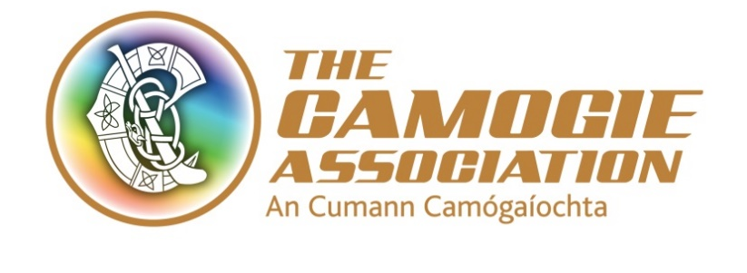
An Chomhdháil Bhliantúil, 2022
(Annual Congress, 2022)
1 & 2ú Aibréan, 2022

Ainmniúcáin (Nominations)

Nominations are being sought in advance of Annual Congress 2022 for the role of Secretary.

This form must be completed, signed by An Rúnaí, An Choiste Contae/Chomhairle and submitted to Sinéad McNulty, Ard Stiúrthóir on or before 4:30pm Friday 18th February 2022.

Submissions are to be emailed to sinead.mcnulty@camogie.ie or posted to:

PRIVATE AND CONFIDENTIAL
Sinéad McNulty,
Ard Stiúrthóir
The Camogie Association
Croke Park,
Jones Road,
Dublin 3.

Forms received after this date will not be accepted and will not be included in the Annual Congress papers

Role Being Nominated For | Ainm | Club | Contae/ Comhairle

Please provide details of Individuals qualities, skills, and experience that will enable the nominee to deliver this voluntary role effectively:

Confirmation that the nominee has been consulted with and is happy for their name to go forward for nomination, and available to take up the role at this time

Confirmation that the nominee is a member of the Camogie Association

Contae/ Comhairle: ____________________________
(Nominating County/Council)

Sínithe ag: _______________________________ Dáta: _________________
(Signed by) Rúnaí an Choiste Contae/Chomhairle

As per An Treoir Oifigiul. Rule 10.2 g the role of Secretary is set out in the extract below:

10.2.g. Four members elected by Congress for a three year term as follows:

(Extract – Secretary Only)

• Secretary: a member with demonstrated administrative experience, nominated by at least one County Board, Provincial Council, International Board or National Education Board, who will serve on the relevant Sub- Committees;

Should a vacancy occur during the term of any of this elected member, Ard Chomhairle will have the authority to co-opt a person to replace the member until the next Congress.

SECRETARY - ROLE AND RESPONSIBILITIES

Agreed by AC on 22nd Aug 2018
Role
The role of the secretary of Ard Chomhairle is to:
- Advise its members on their statutory and other duties under the law and other relevant obligations
- Advise Ard Chomhairle members on their roles and responsibilities
- Advise and support Ard Chomhairle members in their corporate governance responsibilities in conjunction with Uachtarán
- Support the efficient and effective functioning of Ard Chomhairle and ensure that there are the appropriate practices and processes in place

Responsibilities
Compliance
- Act as one of the designated signatories for the Association
- Responsible for ensuring that the list of designated signatories is approved by Ard Chomhairle annually or more frequently if required. The designated signatories also include the Uachtarán, Treasurer and Ard Stiúrthóir
- Ensures that the Association complies with all regulatory, legislative and other compliance obligations in conjunction with the Uachtarán where appropriate

Preparing for Ard Chomhairle and Committee meetings
- Liaises with Uachtarán in preparing Ard Chomhairle workplan for the year, including meeting dates, convene meetings including awayday agenda and date
- Facilitate the provision of the appropriate policy, strategic, management and operational information required by Ard Chomhairle to perform its role from Committee chairs, Ard Stiúrthóir and management
- Facilitate the development of work programmes for Ard Chomhairle Committees and ensure that the Chairs report to Ard Chomhairle on a regular basis
- Ensure that members have timely access to all Committee meetings minutes
- Act as a confidential sounding board to Uachtarán and Ard Chomhairle members

Attending Ard Chomhairle / Committee Meetings
- Attends Ard Chomhairle and Resource Management Committee Meetings
- Advises and supports Uachtarán and Ard Chomhairle in decision making, to exercise collective responsibility in this regard and to manage conflicts of interest and loyalty in decision making
- Supports the Uachtarán as Chair of Ard Chomhairle and supports Ard Chomhairle and its committees
- Advises Uachtarán and Ard Chomhairle on the appropriate procedures to be followed to ensure that due process has been followed in all respects

Follow up from Ard Chomhairle meetings
- Ensures that the minutes of Ard Chomhairle meetings are recorded together with a record of those attending
- Note: Minute taking is normally assigned to a staff member. Draft minutes will be reviewed by Ard Stiúrthóir and the Secretary before they are approved for circulation by the Uachtarán to Ard Chomhairle members

Governance
- Acts as one of the ‘custodians of best practice governance’ in the Association
- Ensures that a regular review of Ard Chomhairle Handbook is undertaken and that it is Fit for Purpose at all times
- Ensures that Ard Chomhairle procedures are adhered to and regularly reviewed
- Ensures that:
1. New member induction takes place on a timely basis
2. There is ongoing development programme
3. The Association is resourced appropriately

Competencies/experience required for the post of Secretary to Ard Chomhairle:
a. Understanding and knowledge of best practice in governance and the role of Secretary
b. Recent and relevant experience in the role
c. Knowledge of the Official Guide Parts I-VII
d. Acts independently at meetings of Ard Chomhairle and relevant committee meetings

