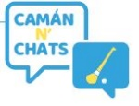 Camán n Chats – Waiver
Name of Event | Camán n Chats Initiative 2022
Club Name
Coordinator Name
Location
Start Date

Insert Camogie CLUB ___________________ strongly recommend that each participant has in place their own Personal Accident or Private Health Insurance which covers them when participating in Camán n Chats . Insert Club Name accept no responsibility for participation injuries that may occur.
Participants are not covered by the club Camogie Personal Accident policy or GAA Injury Benefit Fund whilst participating in this event.

Participant Name (PRINT) | Signature

