Child Safeguarding Statement
Cumann Camógaíochta, Westward House, Baile Átha Cliath 1 D01 F300

Cumann Camógaíochta (the Camogie Association) in accordance with our Code of Behaviour (Underage), our policies, procedures and our legislative requirements has agreed this Child Safeguarding Statement, which is binding on our members.

The basic aims of Cumann Camógaíochta include fostering and developing our Gaelic Games and Irish cultural activities among young people and children. These games and related activities are organised and promoted by dedicated volunteers at Club, County, Provincial and National levels with the cooperation and support of an equally dedicated cohort of staff,

all of whom are committed to the safeguarding of children and young people in our Association as we seek to create a safe environment for young people to grow and develop..

This Child Safeguarding Statement
was agreed by the Camogie Ard Chomhairle on 15th February 2023.

PRINCIPLES TO SAFEGUARD CHILDREN FROM HARM
This statement recognises that in accordance with legislative requirements, and our commitments in our Gaelic Games Code of Behaviour (Underage), (see QR Code 1), to safeguard all children regardless of race, ability, ethnicity or sexual orientation from harm, that the welfare and interests of children are paramount in all circumstances. The Code of Behaviour aims to ensure that children and young people have a positive, developmental and enjoyable experience of Gaelic Games and other activities and that they do so, as far as is practicable, in a safe and enjoyable environment in accordance with the Children First Act (2015) and the Children (NI) Order 1995.

RISK ASSESSMENT
RISK IDENTIFIED | PROCEDURES IN PLACE TO ADDRESS RISKS | QR CODE
Safeguarding training for coaches, Children’s Officers and Designated Liaison Persons and others who work with children which address  Association safeguarding procedures and the risk of harm to children | Gaelic Games Safeguarding Training programmes and policy | QR code 1
Risk of harm when hosting and activity or away trip  Risk of harm through online abuse and social media  Inappropriate use of photography | Code of Behaviour (Underage) Includes directives on; Recruitment, Vetting and Safeguarding Training; Guidance for Coaches, Parents & Supporters on Maintaining Good Practice  & Behaviour; Hosting events, Away Trips & Transport; Social Media Guidance; Photography | QR code 1
Bullying of a child | Anti-Bullying Training & Statement | QR code 2
Risk of harm to a child by an adult or another child including definitions of abuse | Guidance for Dealing with and Reporting Allegations or Concerns of Abuse | QR code 3

In preparing this statement we have completed a risk assessment, available on request from our Children’s Officer, which addresses the potential for harm* to children when they are participating in our games and attending our activities under the following headings:
- Identify Areas of Risk of Harm;
- Club/County and Coaching Practices;
- Complaints & Discipline;
- Reporting Procedures;
- Club Facilities;
- Recruitment;
- Communications and General Risk of Harm.
* Harm means in relation to a child - Assault, ill treatment or neglect of a child in a manner that seriously affects or is likely to seriously affect the child’s health, development or welfare or sexual abuse of a child.

PROCEDURES
Our Child Safeguarding Statement has been prepared in accordance with the legislative requirements contained in the Children First Act
PROCEDURES IDENTIFIED
The following procedures, addressed in our Guidance for Dealing with & Reporting Allegations or Concerns of Abuse (QR Code 3) and Code of Behaviour (QR Code 1) in support our intention to safeguard children while they are availing of our services and activities.

2015, Children’s First: National Guidance for the Protection and Welfare of Children (2017), the Children (NI) Order 1995, Tusla’s Child Safeguarding: A Guide for Policy, Procedure and Practice and as required by our Association rules and Code of Behaviour (Underage).
- Procedure in respect of the management of allegations against any member, non- member or staff/volunteer availing of our services (QR Code 3)
- Procedure for the safe recruitment and vetting of volunteers & staff to work with children and young people (QR Code 1)
- Procedure for provision of and access to Gaelic Games Child Safeguarding Training and information including the identification of the occurrence of harm (QR Code 1)
- Procedure for the reporting allegations of
abuse, protection or welfare concerns of a child to the Association, Tusla or Gateway Team, availing as applicable (QR Code 3)
- Procedure for appointing a relevant person i.e. the Club Children’s Officer who is the relevant person appointed for the purpose of this statement (QR Code 1)
- Our Association, through our relevant units, shall maintain a list of members who, if known, and in accordance with the Children First Act 2015 are specified as mandated persons, regardless of what role (If any), they hold in the Association

Our Club is committed to the Give Respect – Get Respect initiative that seeks to ensure Gaelic Games are promoted and played in a positive, fair, safe and enjoyable manner where players, coaches, spectators and referees Give Respect – Get Respect to and from each other, regardless of race, ability, ethnicity or sexual orientation

MANDATED PERSONS
Mandated Persons GAA/Rounders Michelle Harte mandatedperson@gaa.ie
Camogie Roberta Farrell mandatedperson@camogie.ie
Handball David Britton mandatedperson.handball@gaa.ie
LGFA Paula Prunty mandatedperson@lgfa.ie

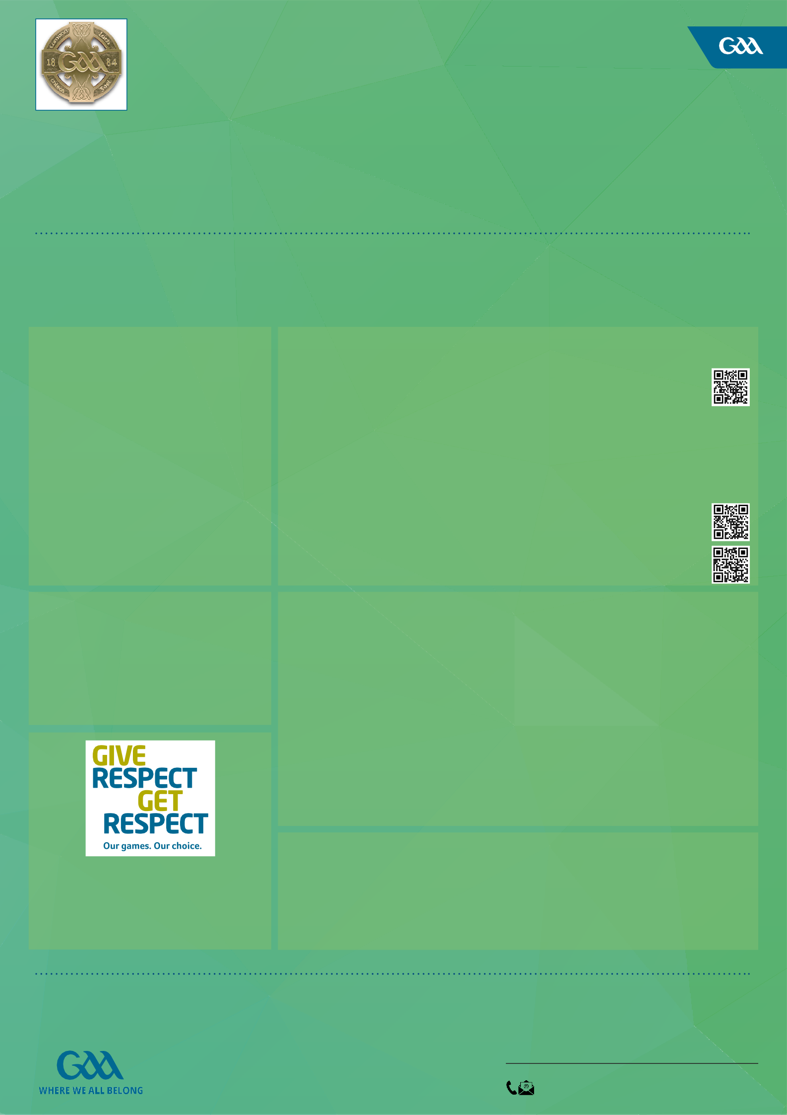
All policies and procedures listed above are available at www.gaa.ie/the-gaa/child-safeguarding-and-protection

IMPLEMENTATION AND REVIEW
Cumann Camógaíochta is committed to the implementation of this Child Safeguarding Statement and the accompanying child safeguarding policies and procedures that support our intention to keep children and young people safe from harm while availing of our service. This Statement, adopted and endorsed by the Camogie Ard Chomhairle shall be reviewed by 15th February 2025 or as soon as practicable after there has been a material change in any matter to which the statement refers.

Roberta Farrell National Children’s Officer

