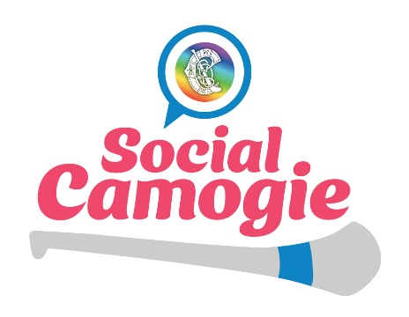
Social Camogie Programme Ethos and Rules and Regulations

All Social Camogie sites should familiarise themselves with the programme ethos and rules and regulations. All clubs and hubs should read below and agree to always abide by these terms.
- Social Camogie a non-competitive recreational form of camogie. This programme provides an opportunity for women to get involved in an exercise in a fun way while meeting other adults playing camogie within the community.

- Social Camogie is all inclusive. It should always welcome women over the age of 25 and who currently do not play any form of competitive camogie at any level (including senior, intermediate, and junior) and would like to take part. They cannot be a registered active player with any camogie club.

- All Social Camogie sessions are fun orientated with the focus on learning the skills of camogie, developing social skills and providing an opportunity for women to be physically active in a relaxed environment. Sessions should be player focused and ensure that the needs are met of the group.

- Participation waivers are used so that participants confirm that they are taking part in this activity at their own risk. All individual participants should be advised to have the necessary personal medical cover in place should they sustain an injury, such as personal accident insurance for social camogie. The club accepts responsibility for the players that take part and will ensure that waivers will be used and signed by each player that takes part. Waivers are in place to protect clubs and should be used even if insurance measures are in place. These need to be sent to shauna.fox@camogie.ie prior to your first session, and then waiver should be at every session in case a new player wishes to try out.

- All events are participation focused, games are small sided and are no more than 10 a side for games.

- Helmets must be worn at all times when playing. Metal bands must be taped. Programme co-ordinators should ensure this is followed at sessions.

- All Social Camogie blitzes are about participation and not winning. There are no winners or losers at any blitzes and no scores are recorded. Blitzes should aim to allow women to meet other people that are taking part while having fun playing small- sided games. There should be elements of socialising incorporated into blitzes – i.e allowing time for chatting and mixing after the blitzes.

- All club must seek prior approval from the National Co-Ordinator (shauna.fox@camogie.ie) prior to hosting their own blitzes. There are lists of clubs taking part online, should you wish to invite various clubs taking part. Note: Club should request waivers from all clubs taking part, to avoid any issues with club insurances and involvement.
  - Failure to seek prior approval for any games or blitzes will result in a team’s removal from the programme without prior notice. These clubs will then not be permitted to attend any Social Camogie events.

