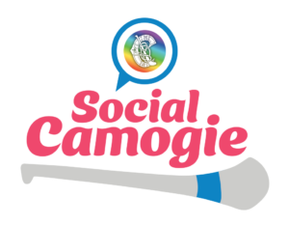
Social Camogie Personal Accident Cover with Gogan’s Insurance
As you are aware, participation waivers are used so that participants confirm that they are taking part in this activity at their own risk. All individual participants should be advised to have the necessary personal medical cover in place should they sustain an injury, such as personal accident insurance for social camogie. To assist clubs in rolling this out we have discussed plans with an insurance provider, to assist clubs with availing of personal accident insurance for players of Social Camogie.
Clubs that register with the Camogie Association are covered by the public liability insurance. All clubs have Public Liability cover, and this covers the programme and club in case of any issues not associated with any natural accidents that occur when playing a sport. Any personal accidents are not covered; therefore, we strongly recommend that personal accident cover is taken out via the club insurers.
Gogan’s Insurance offer personal accident insurance to Clubs to avail of for their Social Camogie Members for a small fee and simple process. Unfortunately, they cannot offer Cover for Individuals. Although any hub or community can avail of this for players but must have group of people to get this cover – it is charged for a group rate but can be levied out where required.
It is advised to contact Gogan’s at least 1-2 weeks prior to your club or hub beginning the programme to allow adequate time to complete the steps to ensure you have personal accident insurance for players in time of the first session.
In order to proceed with cover, you must do the following:

- Contact Gogan’s directly – they require ONE point of contact for the group.
- Mention you are looking for “Social Camogie, Personal Accident Insurance”
  - Gogan’s are aware of the programme.
  - Call on (01) 299 0 299 or fill in the “Request A Call Back” and you can fill in the necessary details in the message box - https://gogans.ie/

- Based on conversations with Gogans and you are happy with the cover, the following steps must be followed:
- Completed Application Form
- Player List & Details Required
- Payment

If you have any questions on the programme or are experiencing issues with insurance, please contact Participation & Retention Co-Ordinator at shauna.fox@camogie.ie

